***Steps to install and configure FTP server (using vsftpd)***

**Step 1: Install vsftpd**

Run command: sudo yum update

sudo yum install vsftpd

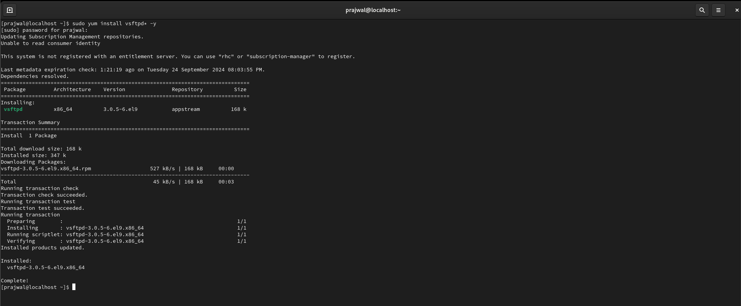

Once the installation is complete, enable and start the vsftpd service:

Run Command: sudo systemctl enable vsftpd

sudo systemctl start vsftpd



**Step 2: Configure vsftpd**

The vsftpd configuration file is located at /etc/vsftpd/vsftpd.conf. Open this file with your preferred text editor and make the necessary adjustments to suit your requirements.

Run Command: sudo nano /etc/vsftpd/vsftpd.conf

For a basic FTP server, consider the following configuration directives:

* anonymous_enable=NO: Disables anonymous FTP access.
* local_enable=YES: Permits local users to log in.
* write_enable=YES: Allows writing to the server (uploading files).
* chroot_local_user=YES: Restricts local users to their home directories.

After making changes, save the file and restart the vsftpd service to apply them:

Run Command: sudo systemctl restart vsftpd

C:\Users\ADMIN\Pictures\Screenshots\Screenshot 2024-09-24 213550.png

**Step 3: Configure the Firewall**

CentOS 9 comes with firewalld installed by default. To allow FTP traffic, you need to add an exception for vsftpd:

Run Command: sudo firewall-cmd --zone=public --add-service=ftp --permanent

sudo firewall-cmd –reload



**Step 4: Create FTP User (Optional)**

If you want to create a dedicated FTP user, issue the following command:

Run Command: sudo adduser ftpuser

sudo passwd ftpuser

Ensure that this user has appropriate permissions to the files and directories you want to be accessible via FTP.

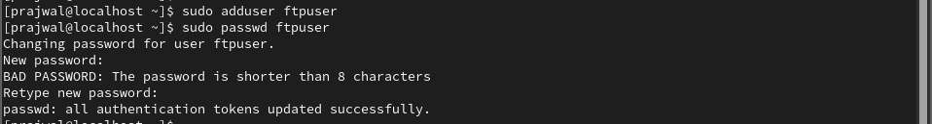

**Step 5: Accessing Your FTP Server**

Now that your FTP server is up and running, you can access it using an FTP client such as FileZilla or from the command line:

Run Command: ftp your_server_ip

Ex: ftp 192.168.73.130

Enter your user credentials and begin transferring files.

